Tru by Hilton Dallas Market Center
1949 N Stemmons Freeway, Dallas, TX 75207

Double Queen $151
King $151
Parking $20 per vehicle per night

To make reservations
https://www.hilton.com/en/attend-my-event/dfwmmru-tcf-3b7d6e4c-919e-4b1d-9c99-0b430f125193/

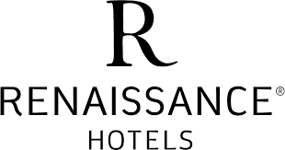

Renaissance Dallas Hotel
2222 North Stemmons Freeway, Dallas, TX 75207

Double/Queen $154 (gov per diem)
King $154 (gov per diem)
Group: FCCLA State Conference Overflow Room Block
Parking, Overnight Valet $32

To Make Reservations:
https://www.marriott.com/events/start.mi?id=1686172427091&key=GRP

